[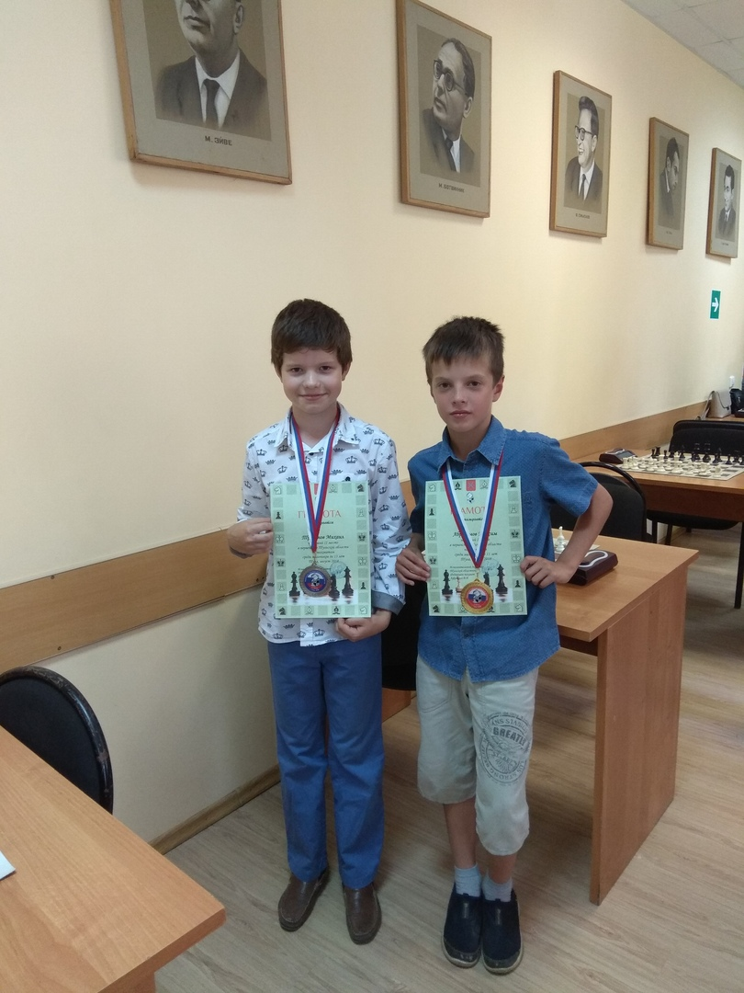](https://vk.com/photo174195152_456240397)